Mechanism /methodology in which we effectively distribute the network traffic across multiple servers in a server pool/farm.

Load balancing site between the client and backend server receive the request from multiple clients and distribute the traffic among multiple server.

What are load balancers and how do they work?

1. Physical device or virtualized instance running on the specific hardware or software process.
2. Incorporated into ADCs application deliver controller designed for improving a the application performance and security in 3 tire application and microservices based application
3. Able to leverage many load balancing mechanism round robin methods, server response time and least connection method.

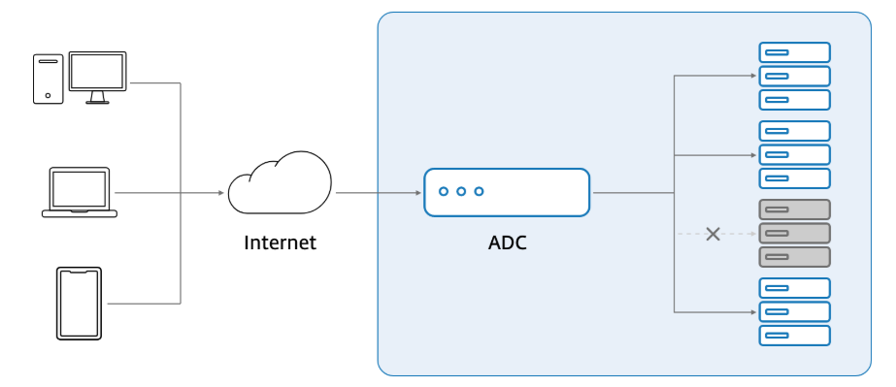

Load balancer detects health of the backend components and resource and send the traffic to the server which can fullfill the request.

It minimizes the server response time and maximizes the throughput of the application and increases the availability of the application.

It acts as application traffic cop that systematically rout the request to the right location at any given point of time there by preventing costly bottleneck and unforeseen incidents.

### **Hardware- vs software-based load balancers**

1.High performance device capable of securely handling multiple traffic from the client.

2. Also contained built in visualization capability which virtualize several instance of load balancers.

3. Allow multi-tenant architecture with complete isolation between the systems.

1. Completely replaces hardware based load balancing with superior functionality.
2. Reduce space and hardware cost
3. Run on common hypervisor, in container with minimal over head

L4, L7 and GSLB load balancers, explained

Digital work places are highly application driven so there is a high demand for the availability of the application. So that customer is not facing any down time.

L4: Layer 4 where in routing decision are made in the transport layer using tcp/upd ports that takes packets from source IP to target IP

L7: Routing decision are made at the top level in layer 7 .Evaluate wider range of the data

GSLB: Global server load balancing manages the load balancing across multiple servers Across multiple data centres so that huge traffic can be addressed.

GSLB used for the applications hosted on the cloud servers.

## What are some of the common load balancing algorithms?

1. Round robin

Easy to implement

Virtual server assign tasks to other server in an ordered list

But won’t consider if the server is already overloaded with tasks.

1. Least connection method

Sophisticated algorithm where we check for the current health of the server and decided if this server can service the request

Server with least request will be assigned with new task

1. Least response time

Based on the server response time to the health monitor request we decide which server can basically serve for this request.

1. Least bandwidth

Based on the amount pf traffic on the server its measured in MBps who can serve the request

1. Hashing method

Varies data sent over the network will be hashed like Ip, header etc

1. Custom load

Query load on individual severe and then one with least load will be assigned with the task.

And ADc with incorporated load balance will help The it industry to leverage the availability and scalability of the application.

ADC offers many other functionality like securing, managing, monitoring application environments and ensuring the best end user experience

Makes sure the load is evenly distributed so the user never experience down time and application always available for the user

Continuously checks for the server health to verify if the server is ready to serve the request.

Some load balances will also trigger the new virtualized server to meet the increase in demand of the resource.